1. Purpose
   1. The purpose of the Dynamic Imports feature is to allow clients/partners/end users the ability to efficiently import external data into the TEKControl portal, without having to use our premade import template files.
   2. Currently (08/24), Dynamic Imports are only available for Logistics Inspections and Custom Forms modules, with addition modules being added in the future.
2. Pre-Processing of Data
   1. Data is imported using Comma-Separated Values files (.csv), which means that there is certain prep that must be done prior to import in order to process properly
      1. **ALL COMMAS MUST BE REMOVED FROM THE FILE. *If this is not checked, data will end up imported into misaligned fields!*** This can be done using the Replace feature (shortcut Ctrl+H), and replacing all “,” with some other character (usually a “;” or “-“ character can be used instead, depending on data), then clicking Replace All. (Below left)
      2. **REMOVE HIDDEN LINE BREAKS. *These are hidden carriage return characters that can impact data*.** To find and replace hidden line breaks, use the Replace feature and in the “Find What” field, use shortcut Ctrl+J, after which you will see a small tick mark one space over; this is the hidden character. Leave the “Replace With” field blank, and then click Replace All. (Below right)  
         A screenshot of a computer

         Description automatically generatedA screenshot of a computer

         Description automatically generated
      3. **Make note of the time format used in the .csv file (mm-dd-yyyy hh:mm, mm/dd/yy hhmm, etc.).** You will need to match that format during the dynamic import.
3. **TEKControl Portal (Logistics) *(See section (iv) on Page 3 for Custom Forms)***
   1. Dynamic imports can be accessed through the TEKControl portal, in the General Administration page, then within the settings for the module. For this section, we will use the Logistics Inspection module.   
      A close up of a screen

      Description automatically generated
   2. In the Logistics Inspection Settings, use the arrows in the top right corner to navigate to the right until you reach the Import tab shown below. Click on that tab, then click on Dynamic Import Logistics Inspections  
      A black rectangular object with a white line

      Description automatically generated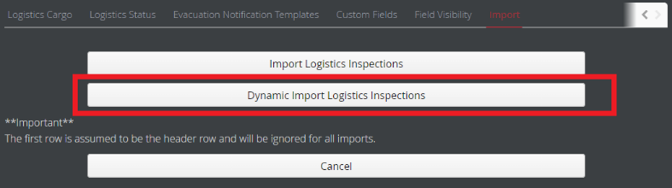
   3. You will now see the window for dynamic logistics imports. At the top of the page are instructions laying out the order of operations for the import process.
      1. First, click “Select Import File” then import the file that you will be using for the import. Once selected, the window will populate with all column headers from the .csv file on the left, and dropdown menus on the right.
      2. Make sure the “Date Format” section matches the data from the .csv file.
         * NOTE: Excel or other spreadsheet programs will sometimes apply a display format while leaving the data unchanged; open the .csv file in a text editor such as Notepad to see the raw data and check the date format there if you are running into a “Date Format Error”
      3. For each column in the file that you want to import, select the DB field on the right that matches it
         * If no DB field is selected, that column will be ignored.  
           A screenshot of a computer

           Description automatically generated
      4. If you are going to use this same type of file in the future (i.e. same column names which will map to the same DB fields with the same date format, such as a daily or weekly import), enter a template name in the box at the top and click Save Template.  
         A white rectangular object with a black border

         Description automatically generated
         * This will allow you to import files in the future by uploading the file, selecting the template, and clicking Import
      5. Once you are ready to import, click the green Import button in the bottom right corner  
         A red and green rectangles with white text

         Description automatically generated
      6. If there were no errors in the date format, the import will take place and you will receive an email with the import log. Any rows/entries which did not process for whatever reason will be listed in that log.
4. **TEKControl Portal (Custom Forms) *(See section (iii) on Page 2 for Logistics)***
   1. Dynamic imports can be accessed through the TEKControl portal, in the General Administration page, then within the settings for the module. For this section, we will use the Custom Forms module.   
      A close up of a text

      Description automatically generated
   2. You will now see the window for dynamic custom form imports. At the top of the page are instructions laying out the order of operations for the import process.
      1. First, you need to select a Site and Form (if you have access to more than one of either)
      2. Next, Click “Select Import File” then import the file that you will be using for the import. Once selected, the window will populate with all column headers from the .csv file on the left, and dropdown menus on the right.
      3. Make sure the “Date Format” section matches the data from the .csv file.
         * NOTE: Excel or other spreadsheet programs will sometimes apply a display format while leaving the data unchanged; open the .csv file in a text editor such as Notepad to see the raw data and check the date format there if you are running into a “Date Format Error”
      4. For each column in the file that you want to import, select the DB field on the right that matches it
         * If no DB field is selected, that column will be ignored.  
           A screenshot of a computer

           Description automatically generated
      5. If you are going to use this same type of file in the future (i.e. same column names which will map to the same DB fields with the same date format, such as a daily or weekly import), enter a template name in the box at the top and click Save Template.  
         A white rectangular object with a black border

         Description automatically generated
         * This will allow you to import files in the future by uploading the file, selecting the template, and clicking Import
      6. Once you are ready to import, click the green Import button in the bottom right corner  
         A red and green rectangles with white text

         Description automatically generated
5. If there were no errors in formatting, the import will take place and you will receive an email with the import log. Any rows/entries which did not process for whatever reason will be listed in that log.